Helpfulness Element 6 Bee Watchful
Etymology, Plant Biology, Environmental Science | Standards-based Learning
Age Level  6 – 11 (Prerequisite for secondary school in chapter activities)  Time 1 ½ hours  Reading: 20 minutes  Game: 30 minutes; Map: 30-40 minutes  Resources  Print-outs  Link to bee dance drawings  Pen, marker or pencil  3 sheets of paper, at least  Objectives  Students will:  - Explain pollination process as an example of biological and environmental systems  - Understand climate change impacts on this process  - Comprehend the value of evolutionary research among scientists and social scientists  - Experience the value of data collection and representation | Teachers, Parents or Self-Guided Learners will  - Study information about the helpful work of bees and the concerns of gardeners and scientists about declining bee populations  - Compare questions about changes in migrating bee populations  - Play a dancing game with family members or classmates based on the instinctive mathematical abilities of bees  - Replicate the mathematical abilities of bees on a map

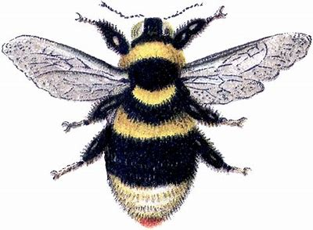
Bee Watchful

We Need Bees
Bees work together to help plant species. They gather the dust of pollen on their feet and carry it from one blossom to the next. They carry the nectar back to their hives to make honey. By dusting off their feet on the plants, they start a process called pollination, which helps plants bloom at the right time.
With the bees’ help, fruits and vegetables and flowers appear, to decorate the world and to feed humans and other species.
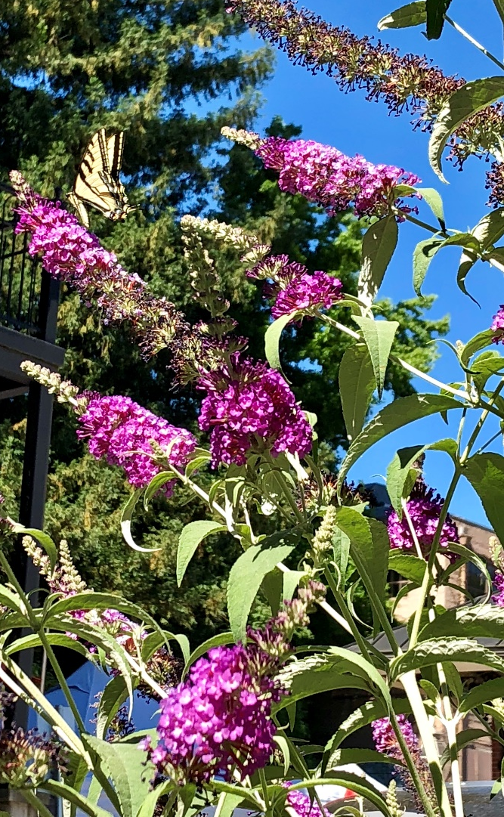
Blossoming plants attract pollinators such as bees and butterflies, but a changing climate can change the timing of the pollination process. When extreme cold freezes the trees in an orchard, the flowers are delayed, and so are the bees. We need bees to stay healthy, to support the food and flowers that grow in the fields.
Some types of bee families have diminished over the years. When bee populations grow smaller, scientists worry.
Researchers to the Rescue
A research team in Puerto Rico began to study bees when climate change reduced the bee population of the world. They wondered, How can we study more than a few bees at a time, to learn how to protect the bees? After all, there are only a few of us, and so many bees.
The researchers developed a kind of “social media” QR code to measure the behavior of thousands of bees at once, in the same way that computers and phones can track the interests of many people based on where they click.
Now scientists can study the health and the social behaviors of bees, who bring food to the world.
What do you think the researchers learned about the bees?
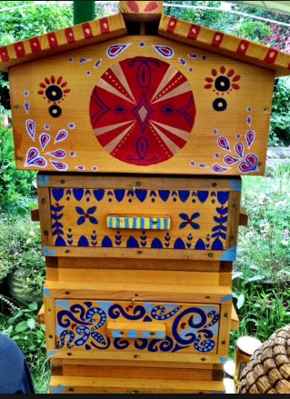
They learned that bees were not really interested in hurting humans who stood back and did not bother the hive. They were too busy helping make honey!
Some people paint beautiful bee houses to attract the bees to their gardens, so they will pollinate the flowers. A teacher named Mrs. Merry Byles Daley invited her friends to come and help her paint this lovely bee house. It had to be colorful as a flower to attract the bees.
How Do Bees Behave?
The social behavior of bees aroused great interest among the Puerto Rican researchers. They wanted to know whether the bees collect honey differently based on their jobs – and even how they become less aggressive based on those roles.
One particular Killer Bee was known for stinging people. However, no one had died from its sting for almost 30 years. The scientists wondered why. They began to study the bees more carefully.
When scientists moved the queen bee away from the hive, the bees went on collecting honey without stinging anyone. The bees had taught one another to be kinder, gentler and to do no harm as they went about their work.
Most of them were foragers and nurses. They did not want to fight but just to protect and collect and take food back to the hive.
Humans do those same things. How many helpers you have seen today? What types of things did they do to help?
What Do you Want to Be?
Human families work best when everyone plays a helpful role. Bee families work the same way.
Some bees are foragers and some are nurses.
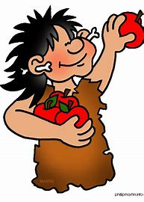
A nurse bee feeds the larva (wingless baby bees) after they hatch. The larva can only eat jelly from the hive at first. After three days, these youth can eat “bee bread” or honey and pollen, until they develop their protective covering, becoming pupa (a stage much like entering a cocoon). When they emerge as full-grown bees, they too will inherit a special role of service as nurses or foragers in the bee family.
Meanwhile, the forager bee finds a food source such as a flower. It tells the others where to locate the flower’s pollen by moving about. When the food is only a short distance from the hive, a forager bee moves in a pattern called the round dance. To help the others locate food farther away, beyond 200 meters (or about 200 yards), a forager bee performs the waggle dance.
Look at the link. Draw the patterns of the bee dances.
https://www.everyething.com/Bee-Dance#:~:text=The%20bee%20which%20locates%20the%20food%20source%20at,How%20do%20honey%20bees%20communicate%20with%20each%20other%3A
Dance Like a Bee
In an outdoor space, play a game in which you travel in a certain direction. Other members of your family or your group of learners must call out “Round dance!” or “Waggle dance!” based on the pattern in which you move. See if you can perfect each dance.
Those who guesses correctly becomes foragers, because they followed you to the food source. When it is time to stop for a human meal, they will have the honor of helping to serve the food.
Whoever is left in the dancing game may act as a nurse bee, passing the food around at the table, to make sure the smallest children have had enough (especially enough bread and honey).
Round Dance
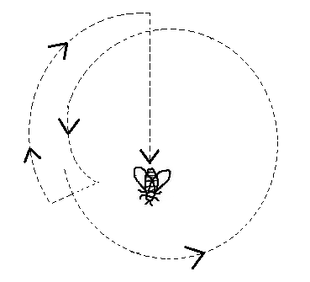

Waggle Dance
