Times of Peace
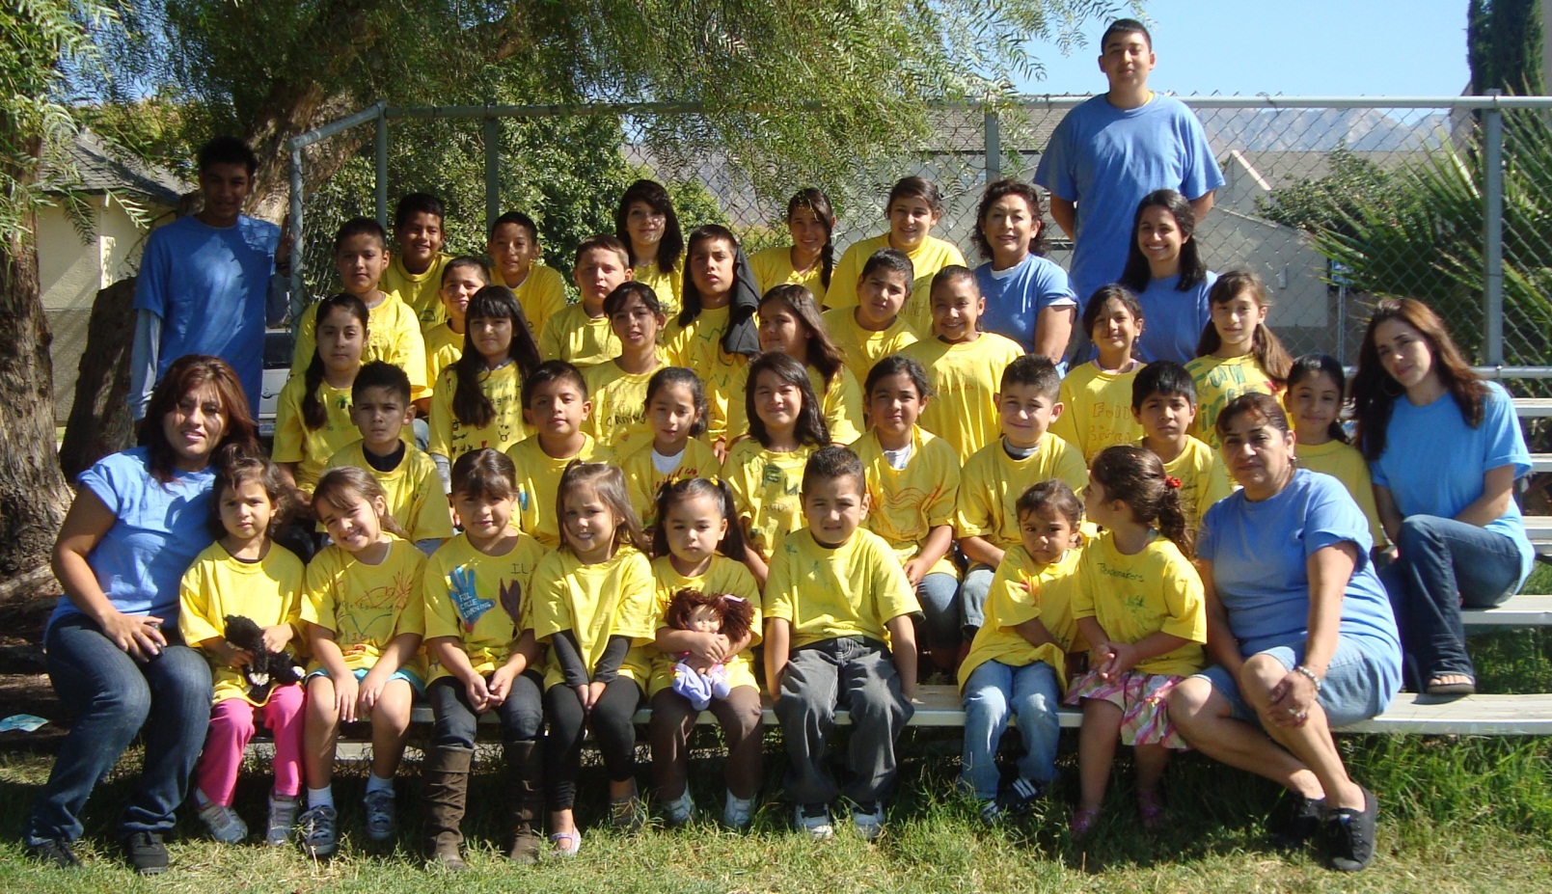
Rancho Sespe Summer School 2011
Student Newspaper

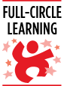
Acknowledgements

Habits of Humanitarians was the module use for this year Full Circle Learning Summer School at Rancho Sespe. Our Habits of Heart were Universal connectedness, Farsightedness and Humanitarianism. Thanks to the Mona Foundation and Full Circle Learning our program was able to run for three weeks five days a week starting on July 11th and ending July 30th 2011
Our program was also possible thanks to the support of the managers from Rancho Sespe, Jose and Claudia Hinojosa, and their Staff. Also, thanks to all of the wonderful parent volunteers, Estela Villegas, Maria C. Magaña, Salvador Aguilar, Maria Rodriguez, Alma Avalos, and our volunteer students Christian, Jordan, Victor and Stephanie.
An Especial thank you to our aides & teachers Leticia Abrego, Celia Bejar, Gonis Tobias, Roya Tabrizi, and Maria Enriquez for their help, effort and dedication to the program.
Thank you to all the students for participating and dedicating their time and effort to build their skills and mastered the habits of heart.
With gratitude
Sugey Lopez

Habits of heart accomplished

As every year the summer school students, Peacemakers (preschoolers), Rebuilders (elementary), and Ambassadors (secondary students) from Rancho Sespe gather together to participate on the lessons and projects. Every morning the students would get together as a big family, to practice songs, to later on present them to the host in the field trips. -The students presented the songs and gifts to the host to thank them for dedicating their time practicing one of the habits of heart learned by the students during the summer program this year.
Students not only gather together to connect with music, but also demonstrated that everybody could be community heroes when we work together and value respect, peace, caring and learning. Daily students demonstrated their values by trying to reach the goal of moving a representing doll, to the end of the line every week at the poster of code of ethics.

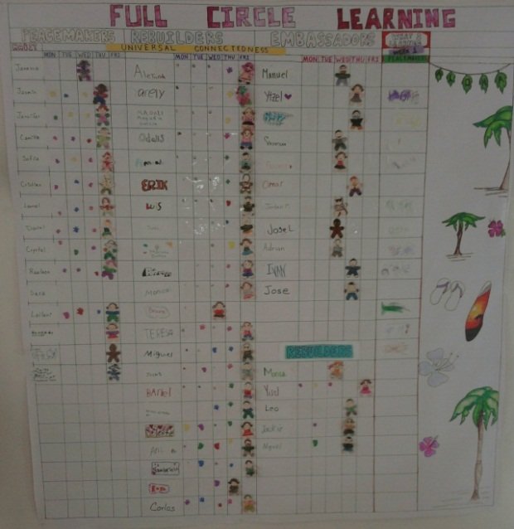

First week Universal Connectedness

This year the summer school started the first week with the habit of heart of universal connectedness. The students were able to understand the concept that “we are all connected, as one human family,” and to bond with students unlike themselves.
The peacemakers learned different ways of how the universal human family can connect. For example, through art humans can find similarities and distinctions between cultures. The peacemakers created a mini- art gallery to exhibit during the parent night. They also worked on painting a bus to remind them that transportation connects people from distant places.

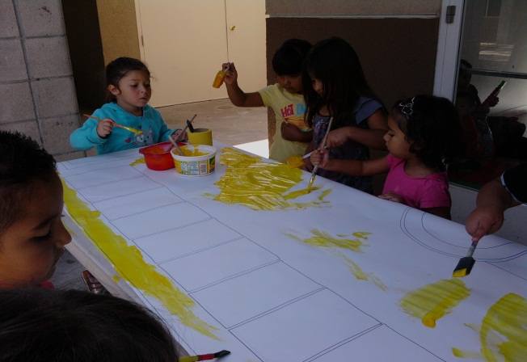
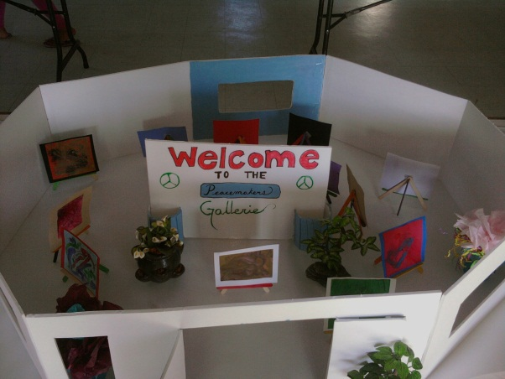
Students painting big bus Mini-art gallery
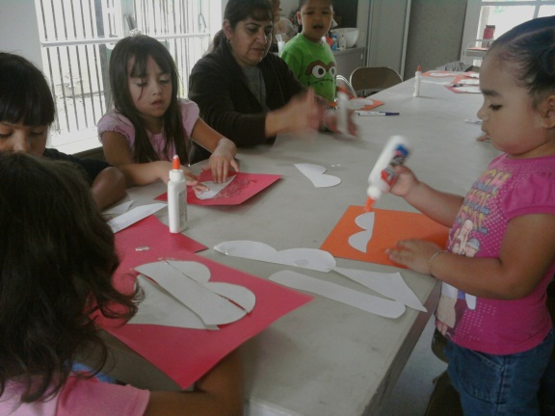
Peacemakers working on connecting a heart to later on presented as a gift to the Arc of Ventura County, to connect a bond with disable students.
The Rebuilders were able to share experiences of how they connect or can connect with distant friends and family members, by mail or technology. Also, talked about how they can make friends around the world when sharing their qualities and developing bonds.

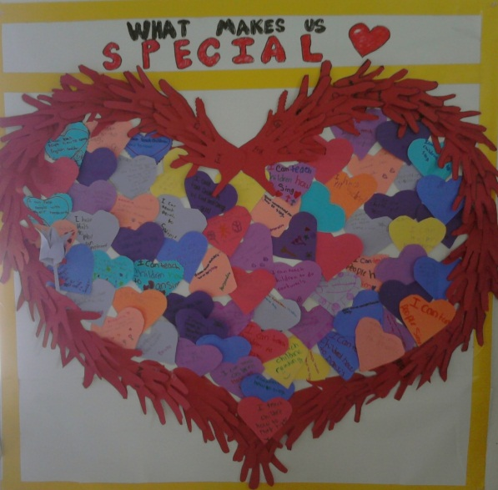
Heart made out of helping hands. Students wrote three things that make them unique on heart shaped notes. Each student was to describe how they can use their qualities to connect with people and help the world. They connected all their hands together to create and decorate a big giant heart.

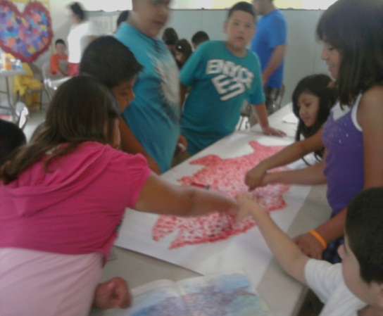After the Rebuilders class read the book Swimmy they all did a big red fish made out of every ones fingerprints representing how if we connect all our strengths together, we become a "Super Strength" to help each other.
Rebuilders also got a chance to work on an appreciation token, after reading the book Eddie. They decided to work on a rainbow for the ARC organization. Students chose a rainbow as a symbol because when all colors connected, they can create a beautiful rainbow. The colors represented on how different we all are weather we have disabilities or not.
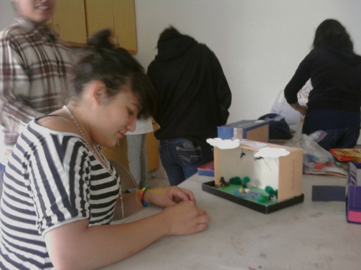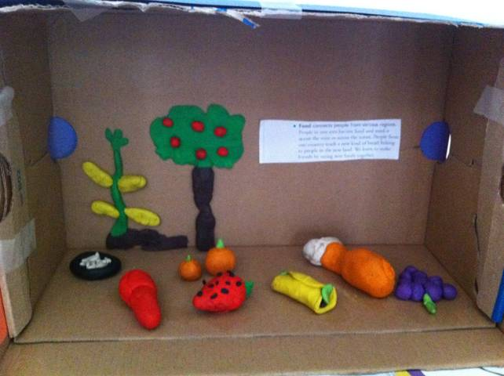
The Ambassadors got into groups and each received a paragraph on a specific way we are connected. The few of the different ways we can be connected within our local and global communities are: art, technology, food, transportation, and nature. Then each group got the chance to translate what the connections look like into shoe box art, followed by presenting to the group on what the theme of the box is and how they translated it into art.
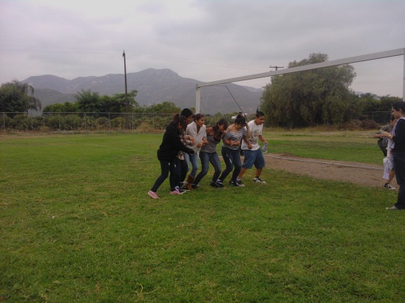 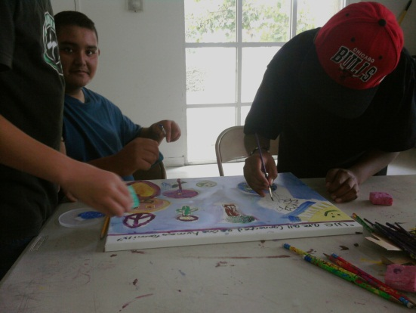The Ambassadors put what they learned about Universal Connectedness. They tried to learn how to use consultation and each other strengths to overcome obstacles and achieve their goals. We tried to do three-legged races and then see how many Ambassadors could get from one side of the field to other being tied together.
The students took the time to paint a gift for the adults who are at the ARC of Ventura in Santa Paula. The theme for the week, Universal Connectedness, helped the Ambassadors to reflect on the various ways we are all connected. The quote they focused on was, "We are all connected, as one human family" and they brainstormed different images that represent that statement. They transferred those ideas into paintings.
To successfully end our first week and to have students connect a bond with someone unlike themselves. Students along with some parent volunteers participated on a field trip to the ARC of Ventura County, a program that helps disable adults to depend on themselves. During the trip they met the Case Manager, Jesenia Gonzales who explained to the Students the different abilities that each individual has at the ARC organization. And how through their abilities they can connect to the world when they participate on the Special Olympics
The peacemakers, rebuilders and ambassadors presented the songs learned earlier in the week along with the gifts that each class worked on, to present to the host and some of the ARC students that attended that day of the trip. Everybody enjoy the presence of each other that Jesenia allowed the Rancho Sespe students to play bingo, make flowery pens and beads bracelets along with the ARC students, while the students were enjoying their presence with the different activities, a lady played the piano for everyone to enjoyed even more.
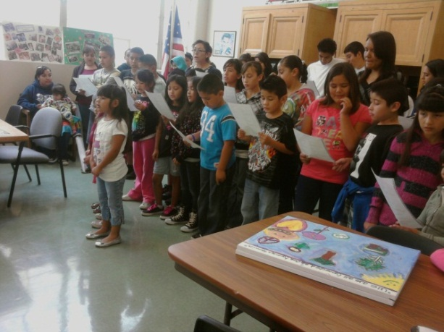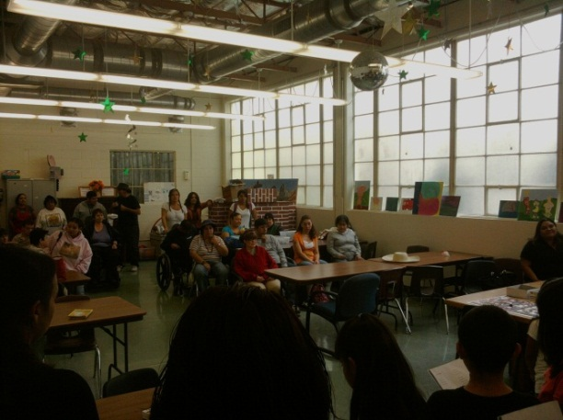
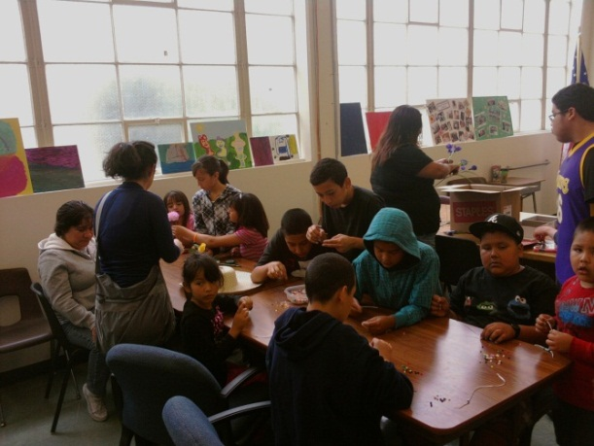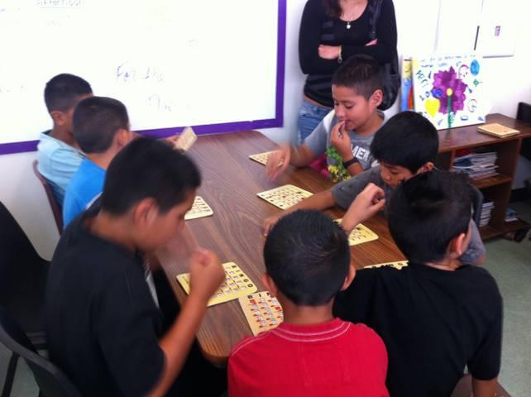
The students are working on arts and crafts to create bracelets and flower pens with the residents. While some students took the time to work on crafts, others played bingo and helped to call out the numbers during the game.
Second week Farsightedness
Excited to start the second week, with the habit of the heart of farsightedness. Some students arrived earlier than the usual. During this week the students were able to identify different choices to wisely make every day looking at the long term effects.
The peacemakers made some glasses to use them as a metaphor, for looking ahead in their mind and to think of the consequences of their choices. Then they role played samples of how they can practice farsightedness wearing their glasses. An example was for them to think what would happen if they pulled a pet’s tail, some of the answers were that the dog or pet could get angry, hurt and bite.
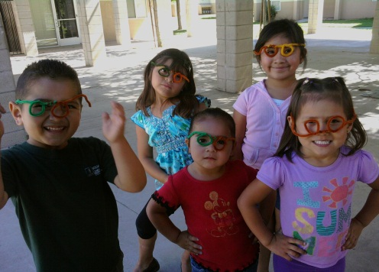
The peacemakers also learned that water is one of the most important resources on earth. Students worked on a poster that demonstrated a clean park next to a park not so clean. Students were able to visualize and think ahead that if we do not take care of our water and our environment, the world can end with dirty water, dried trees, and sad people.
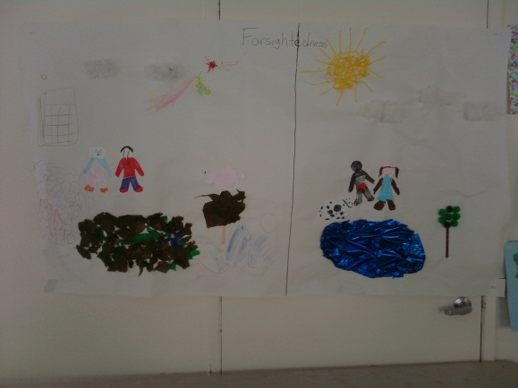

The rebuilders were able to wonder and visualize a contaminated earth and recognize ‘the value of looking ahead, to prevent or correct global problems like it is global warming. Some solutions from the rebuilders were to prevent the global warming by recycling, and not wasting water, that way instead of trading oil for food they could find or use more land for farms and feed more people.
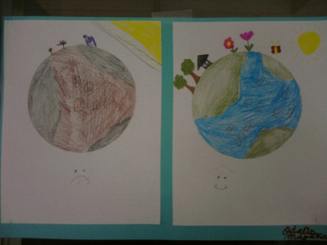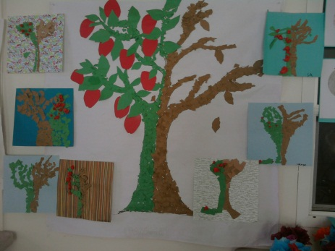

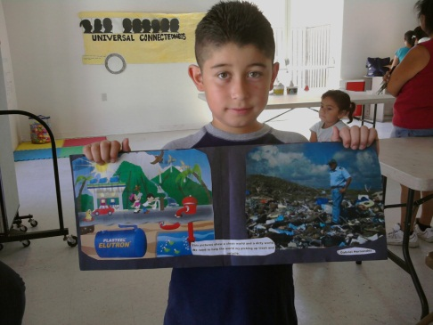
Gabriel made a research at home, thinking of how we can take care of the water to prevent a trashy environment in a few years.

Ambassadors
While learning about Farsightedness, students learned about hunger and how it affects millions locally and globally. They had the opportunity to paint flowerpots so that they could fill it with soil and seeds the following week. They will take care of their plants to have it symbolize the steps we can take today for the best outcome later.
With each lesson was an attempt to link a game with theme. In this game, tidal wave, the students had to transfer the water from the front of the line to the bucket in the back of the line. They were only allowed to use one bowl and had to pass it backwards over their heads. With the appropriate planning so that they could have the best outcome in the end, students quickly learned that the task required patience, precision, and support for their fellow teammates.
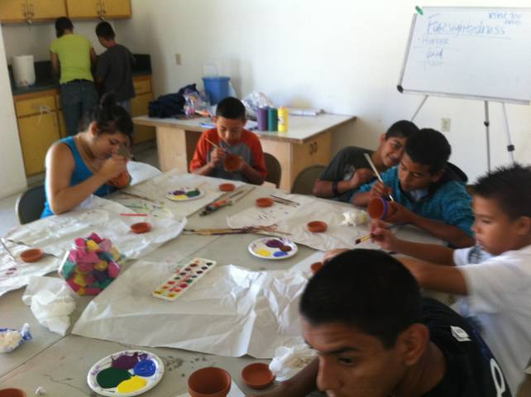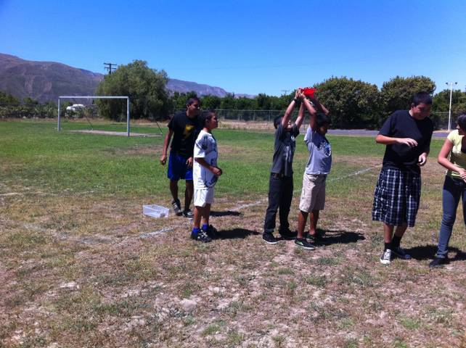
For the field trip the students attended Food Share located in Oxnard. Food share is a non-profit organization that gives food to certified agencies who serve hungry people. During the tour, Karon Jensen Food Bank Coordinator demonstrated to the students how they process the food storage and how it then gets distributed. The student excitement occurs when they got a chance to walk through a huge refrigerator/freezer. Towards the end of the tour the students got the opportunity to get together and color coloring pages to give as a thank you card to their local farmers during the Ventura County Fair. Last but not least, the students all came together to perform the songs they had learned throughout the week. They also presented some gifts that each class had worked on as a way of thanking them for their hard work and dedication towards the community.
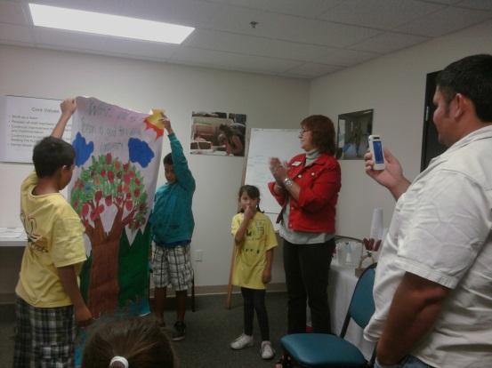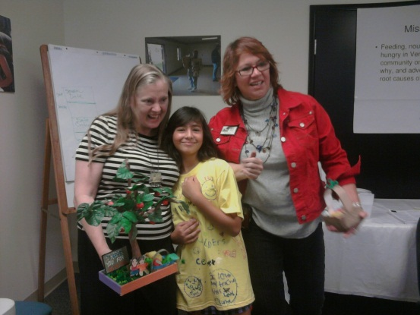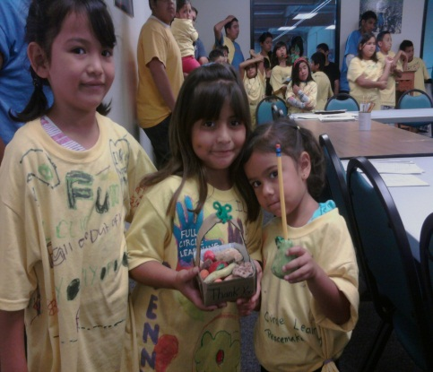
Third week Humanitarianism
The last week of the summer program was one of the busiest weeks. Each class had lessons to cover and many service projects to work on. The habit of heard that we learned about on the last week was Humanitarianism. Students were able to discuss about the many different ways how they can practice humanitarianism with not only their family members but with the community as well. Some ideas that the students shared with us were to always act in a respectful, kind, sacrifice, and loving way.
The Peacemakers worked on making a humanitarianism community by searching and learning about other cultures and by paying attention to their house structures, each person had a heart on their chest with the word humanitarianism spell on it. They also got the chance to build a happy human family where each member had responsibilities. For example, they had to always be helping each other, shared and cared for each other.
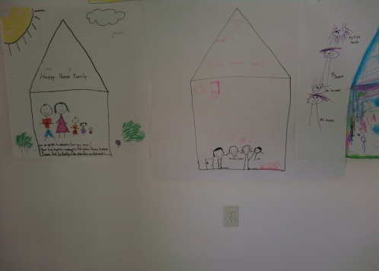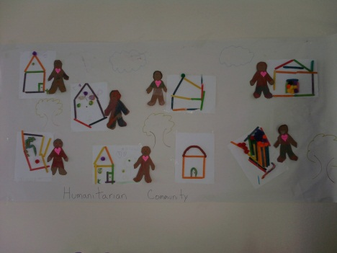

The rebuilders got a chance to once again introduce themselves as members of the human family, starting with their teacher Mrs. Enriquez “my name is Mrs. Enriquez and I Am a member of the human family”. Then teacher made a small circle and asked each student to write their name. Then a longer circle around the first was made and students wrote their immediate family. Students were asked for other family member to be place in another larger circle and so on. The message was “who else is included in our human family which included neighbors, community other countries and the world.
During the last week for the habit of humanitarianism the ambassadors talked about what responsibilities are in our family, the community and the similarities between the two. Then they read some stories on humanitarians and did some math on statistics in girls and their access (or lack of access to education).
As a whole group, the students prepared for parent night with gifts and certificates to give out to the parents. During the parent night the students presented their work and songs done throughout the weeks. Then as the teachers presented certificates to the students for achieving the habits of heart, the students presented certificates to their parents as well for mastering many habits of heart. During the parents night the students also honor the mangers Jose and Claudia hinojosa for supporting us every year with the program. After the ceremony the students had the honor of serving their parents food and share a bonding moment with them. The last two days of school as an act of humanitarisim. Students were busy preparing gifts for community members. Their service this week was to prepare fruit baskets & bags of food to deliver to the local seniors in Rancho Sespe. The students brought some of the food from home to share with the seniors. With this service the students practice simple math skills, like dividing the equal amounts of food for the six seniors that we had in our list, and to calculate an estimated amount of money waste per basket and bag of food. After delivering the baskets to the seniors, the students enjoyed a Hawaiian party with pizza and games.
Furthermore, the students got a chance to prepare a gift to share with Haiti, Their global partner this year. They made an art project on canvases each class worked on canvases to afterwards connect them together with the meaning that when we connect by recycling and taking care of the environment we can change the world.

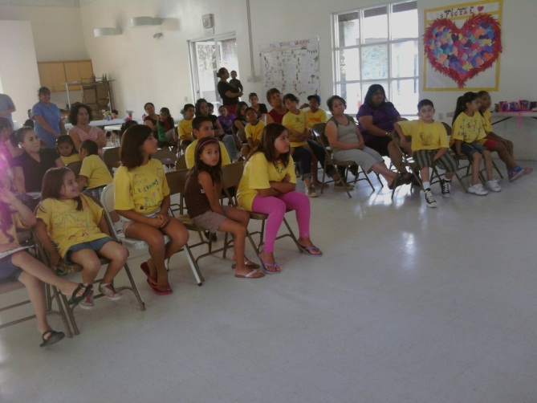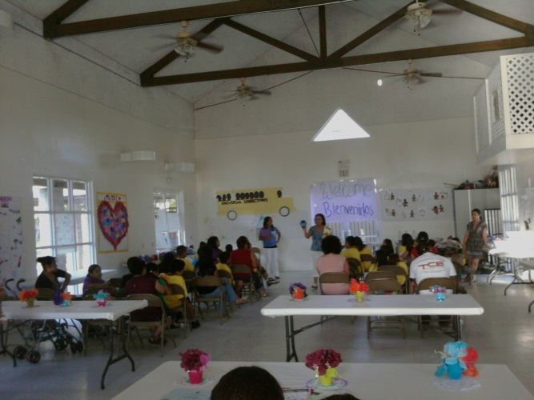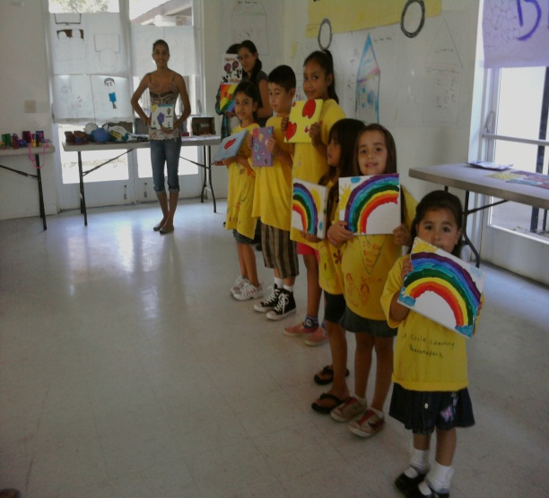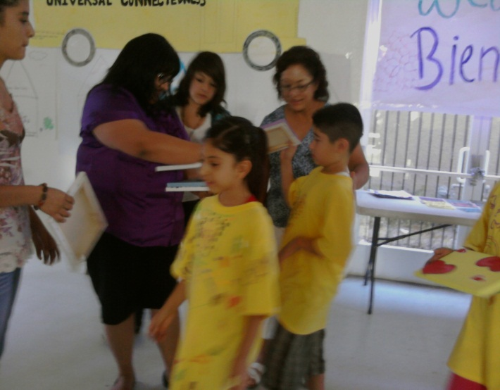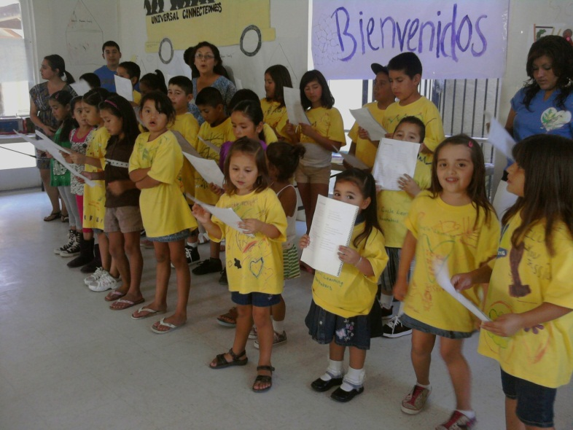
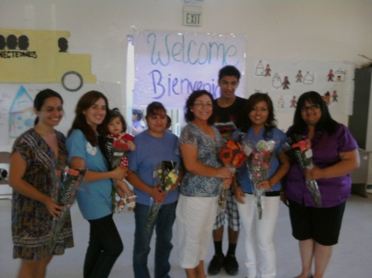
Thank you to the Mona foundation, Full Circle Learning
and
Our warmest appreciation and Love to Mrs. T
We all miss you

