Habit-of-Heart Resiliency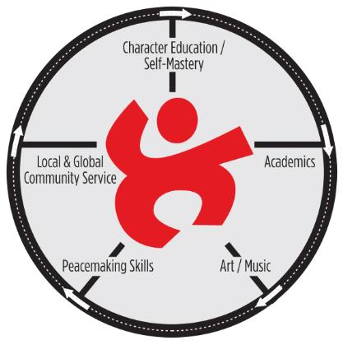

Distance Learning Unit  Full-Circle Learning | Habit-of-Heart Theme: Resiliency
Lesson Plans for Home Implementation  (For Teachers, Parents and Self-Guided Learners) | One-Week Unit  Recommended Grade Level: 6-9  (age 10-15)  Mixed media for adaptability
Time: 5 min.  Materials: 2-minute video intro and/or written intro, cup of steamy water | Element 1: Sense It – Intro to Resiliency  - Water evaporates into steam; it never disappears but just changes form. The river gives water to the clouds and weathers all seasons, reviving itself again.  - Humans can practice resiliency just as rivers do.
Time: 30 min.  Materials: 2-minute video and image of conflict bridge  10 papers, leaves or stones to represent steps on a bridge | Element 2: Show It – Making Peace for Resiliency  - Knowing how to create peace with others brings resiliency for both partners.  - Consider the example of two siblings on the conflict bridge.  - Work out a real or imagine conflict with another young person at home using no judgement. Be the first to make a statement showing empathy.
Time: 30 min.  Materials: 4-minute audio, with image of story | Element 3: Storytell It  - Put yourself in the story of someone called upon to lead others down a polluted river. If the situation were real, how would your resilience help save lives?  - Discuss with a family member how this situation relates to helping one another through rough channels.
Time: 30 min.  Materials: Audio-video, text | Element 4: Science: The Gifts of Rivers  Learn about what rivers give us:  - Water to drink and bathe for humans, birds and animals  - Water for shade trees  - Moist soil to prepare the soil for growing smaller plants  - Water to collect for washing  - Water that evaporates as droplets to feed the clouds and cool the earth.  Threats to rivers include:  Biodiversity loss, drought and flooding that come with climate change  Illness from zoonotic disease  We can become resilient by studying and acting on what we know about:  - Climate change  - Adapting the ways we grow and store food  - Water conservation  - Disease prevention  - Protecting one another
Time: 15 min.  Materials: Video/s and text | Element 5: Music: A River Is a Place  - Listen to the song recorded by musicians who visited a dry riverbed during a drought.  - Play the song again and sing along. The lyrics say, “A river is a place that sometimes has some water flowing through it.”  - Incorporate the song into a lesson for the family on the importance of conserving water.
1 hour  Materials: Video and Text | Element 6: Poetry: Rivers of the World  - Listen to ten poems, read aloud.  - Follow along with the text.  - Picture the setting of each poem.  - Answer the questions about the poems.  - Pick a favorite to recite for the family.
Time: 45 min.  Materials: Instructions, paper, straw or ribbon, marker/paint and brush or stick | Element 7: Share It – Ribbons of Rivers (Video)  - Create a space for a river tribute inside or outside, using the map as a guide.  - Teach the family about the importance of conservation and place the “river ribbons” on the map.  - Invite family members to assist with watering chores in exchange for adding to the artistic features of the tribute space.
Time: 1:45  Materials: Video and instructions, clay made of natural materials | Element 8: Send It – The Clay Pot Project  - Learn about the origins and global uses of clay water pots.  - View the instructions for creating a clay pot.  - Use local materials or back-yard materials to create a clay pot.  - Send the pot to honor a nearby or distant artist who makes and carries clay pots
Time: 15 minutes per day  Materials: Notebook or a few sheets of paper | Element 9: Sustain It  - Review a plan for keeping a journal to maintain resiliency.  - Write or draw each day’s challenges and how you overcame them or your plan for overcoming the next day’s challenges
Time: Preview Time before beginning lesson plan unit and review time after lesson plan unit, as needed  Materials: Text | Element 10: Glossary  - Definitions and spellings of some words used in the unit are defined here.

Resilience Distance Learning Unit Materials List
(Paper Version will also be provided; this version should be adaptable for website, Whatsapp, Facebook or radio/TV use)
Element 1: Sense It – Introduction to Resiliency (Video and Text)
Element 2: Show It – Making Peace for Resiliency (Text)
Element 3: Storytell It – (Audio and Instructions)
Element 4: Science – The Gifts of Rivers (Audio-Visual & Text)
Element 5: Music – A River Is a Place (Video and Text)
Element 6: Poetry: Rivers of the World (Video & Text)
Element 7: Share It – Ribbons of Rivers (Text Instructions)
Element 8: Send It – The Clay Pot Project (Video & Text)
Element 9: Sustain It – Journaling for Resiliency (Text)
Element 10: Glossary – Preview and Review (Text)

