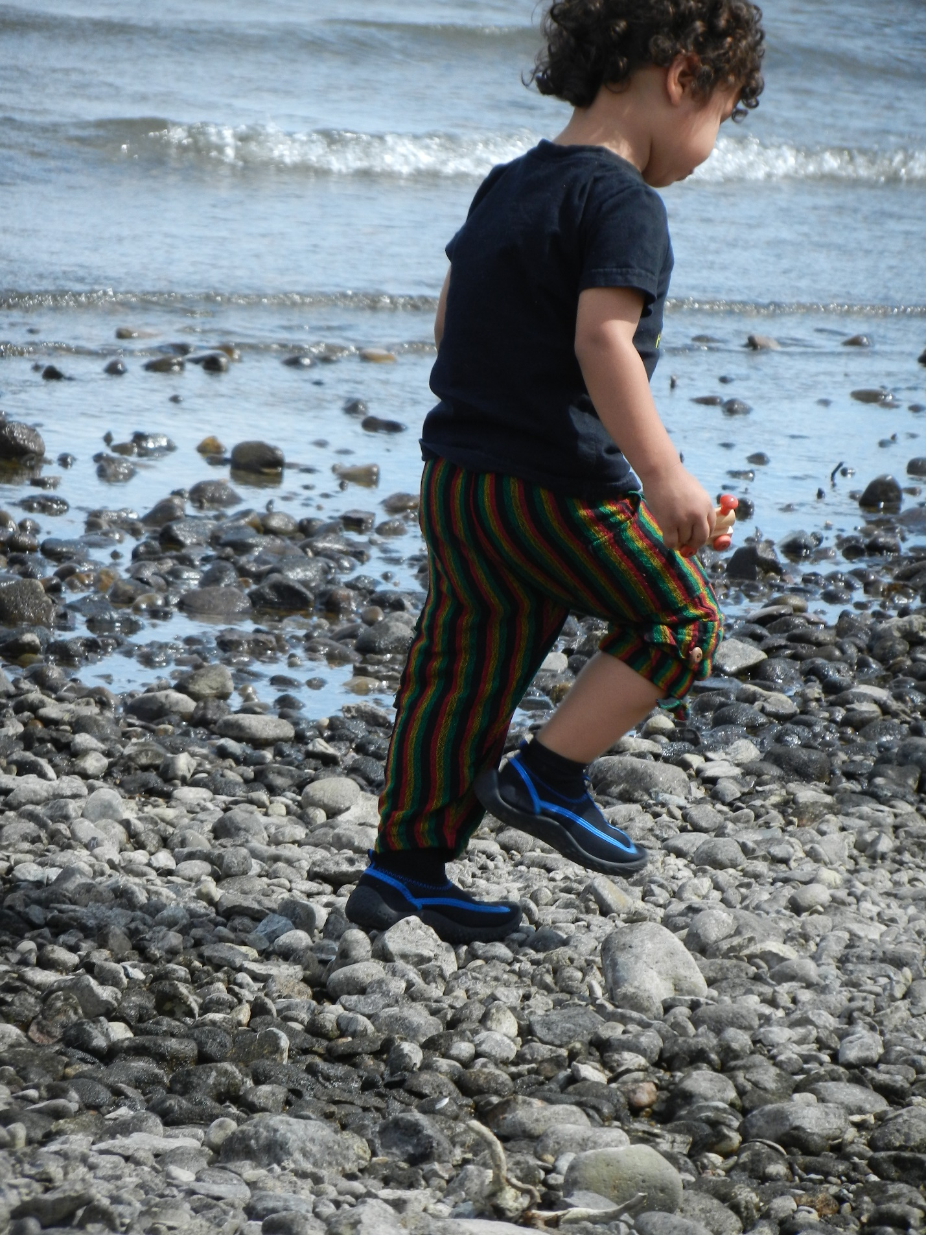
Element 4: The Gifts of Rivers
What gifts do rivers give us?
They give us water for our use in playing washing, admiring nature, and of course, for drinking.
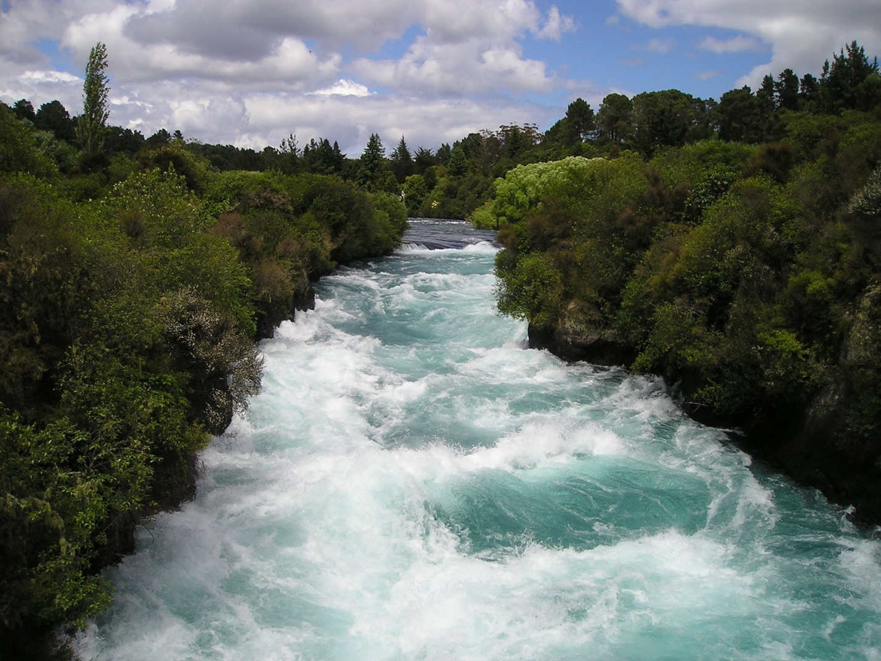
We all need water to live. Our bodies are 98 percent water. A new mother needs 8 cups a day, but a mother cow drinks 20 gallons a day!

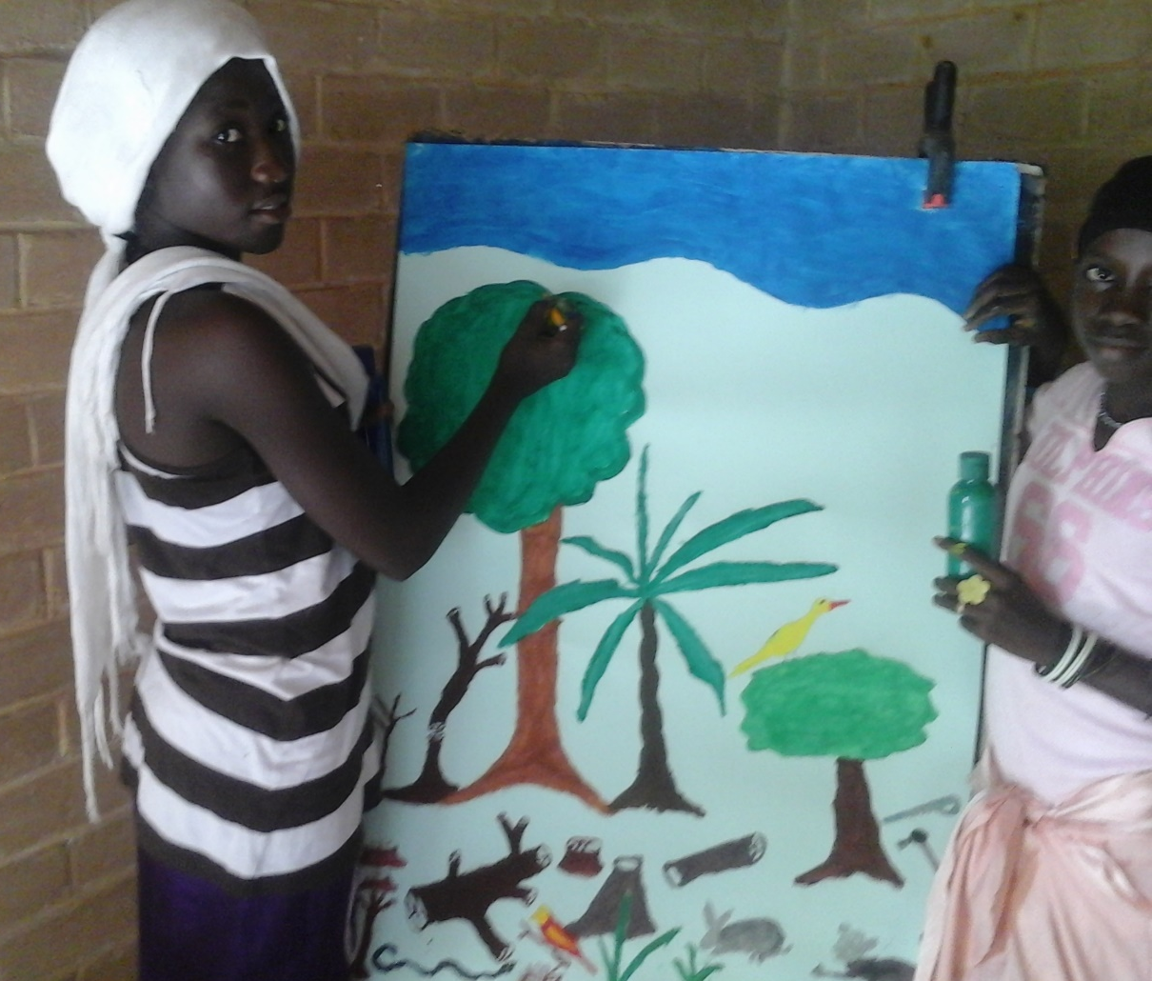
We also need water for shade trees. Some trees are good at conserving water. They sip all day from the wet soil. Dogwoods, willow trees, and myrtle trees like lots of water, but acacia trees, ebony trees and evergreen trees do well with very little water.
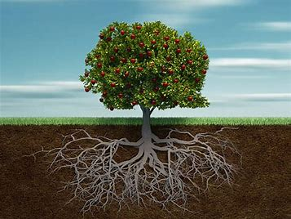
The river quenches the thirst of a tree. The shade and the roots of the tree can then help to keep the moisture in the ground, so food crops and other plants can grow, keeping the world in balance.
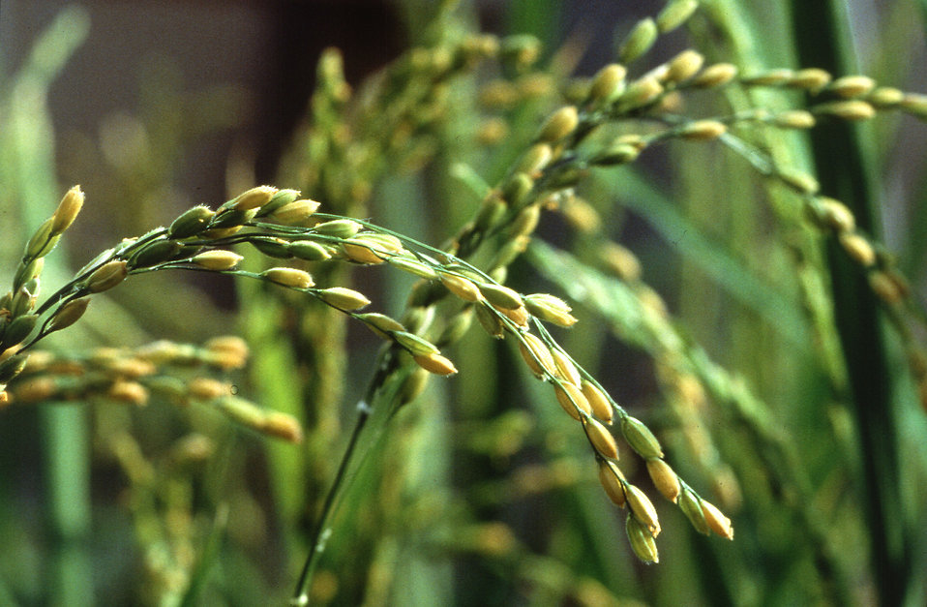
Rice, cassava, nuts and sweet potato all need water to grow. We must tend the land in the dry season to prepare it for planting.

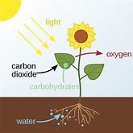
Plants give us oxygen to breathe. They soak up carbon dioxide so dangerous to our planet’s atmosphere. A high level of CO2 has overheated the planet, drying up farms and riverbeds.
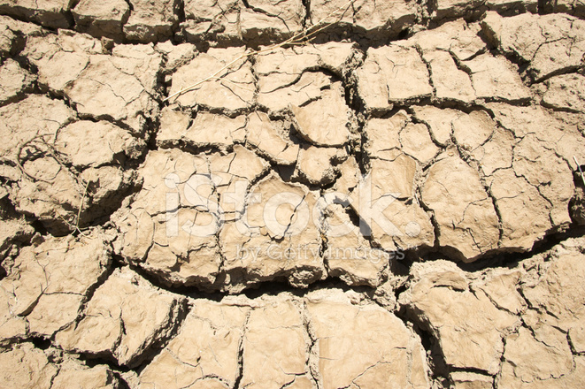Increasingly, climate change has brought on droughts and flooding – sometimes in patterns that invite too little and sometimes too much water.
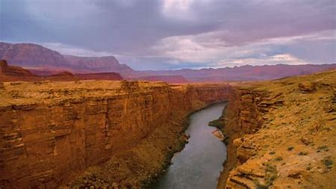
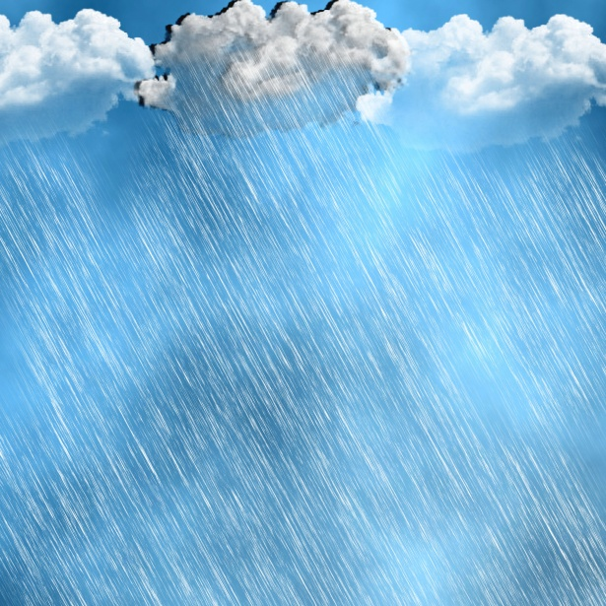Rivers seed the clouds with water, but a layer of greenhouse gases can trap the water droplets in those clouds, as if earth’s rooftop keeps the heat from escaping. When hot and cold air systems collide, we see high winds, rainstorms, floods, and droughts.
Even the animals sometimes must relocate to adjust to the heat. Habitat loss, animal migration, and deforestation result in loss of biodiversity, and as animals and humans shift into closer contact, the likelihood of zoonotic illness (viruses of animal origins) increases. These include Ebola, Zika, Dengue, and the novel coronavirus, among others.
Some of our common diseases occur where water pools in a swamp or standing ground water in a back yard, where mosquitos might come to lay their eggs.
A river has running water. Water that moves is less likely to become a breeding ground for mosquitos. If you have a stagnant pool, where water stands still, please ask your family to help fill it up, so no one gets a water-borne disease. If you can get grapefruit juice or orange juice, share it with the young children in your family, to prevent malaria. The quinine is helpful in curing this disease. Meanwhile be grateful for waters that move, so mosquitos will land elsewhere.

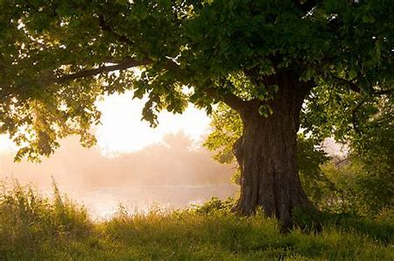

What can we do? We can keep learning.
We can study new ways to reduce climate change and to prevent illnesses.
We can care for the land.
We can adjust our gardens to the changing growing season. We can appreciate, store, and share the food we do have.
We can protect others and ourselves against illness by studying causes and prevention.
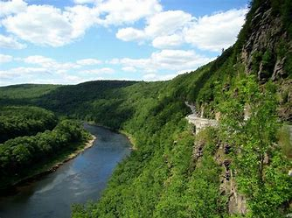
We can keep our rivers clean, conserve their water and let them do their job.
One more thing—we can try to grow as resilient as the river.

A river has running water. Water that moves is less likely to become a breeding ground for mosquitos. If you have a place where water is stagnant, or stands still, help your family fill it up, so no one gets a water-borne disease. If you can get grapefruit juice or orange juice, share it with the young children in your family, to prevent malaria. The quinine is helpful in curing this disease. Meanwhile be grateful for waters that move, so mosquitos will land elsewhere.

Now that you know what rivers can give us, what can you give back to the rivers?

